**Document for Cam Call Plugin**

After installation of plugin you have clicked on setting tab. Now go to cam call plugin setting. Now add the link and choose your widget color . after click on generate widget button. Now you widget is genetared.

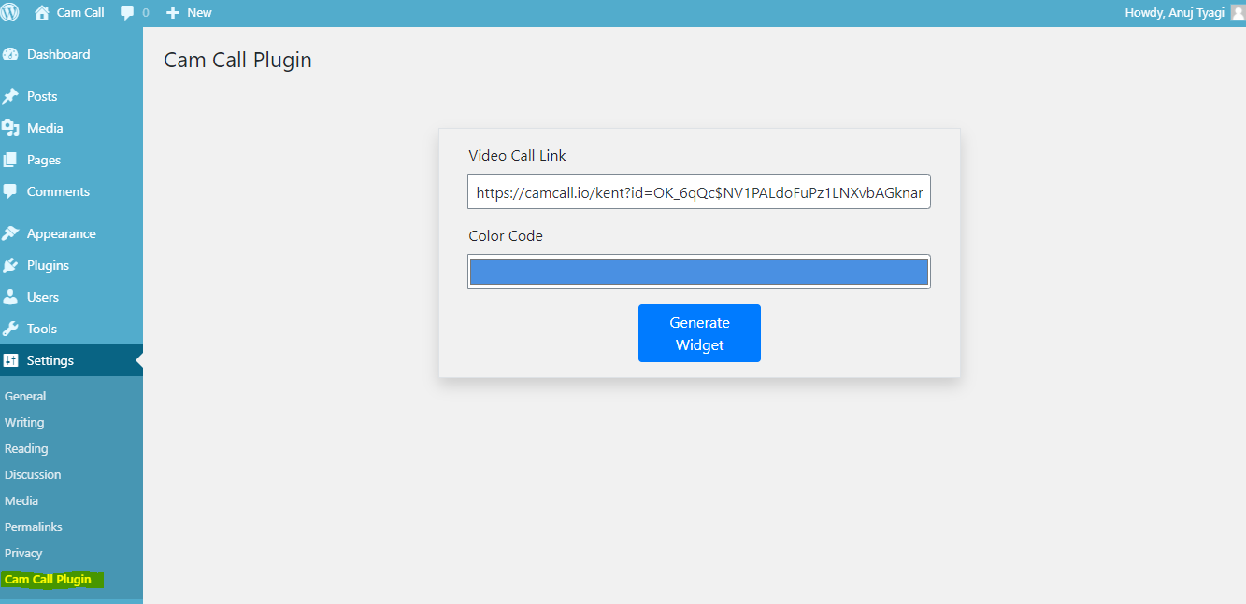

Now add the short code

**Use this Short code – You can use this code anywhere you want.**

**For Word press admin panel pages-**

**[camCall_app]**

For theme pages -

<?php

include_once( ABSPATH . 'wp-admin/includes/plugin.php' );

if ( is_plugin_active('chat/chat.php') ) {

echo do_shortcode( '[camCall_app]' );

}

?>

When you have added the short code , now your widget look like this->

